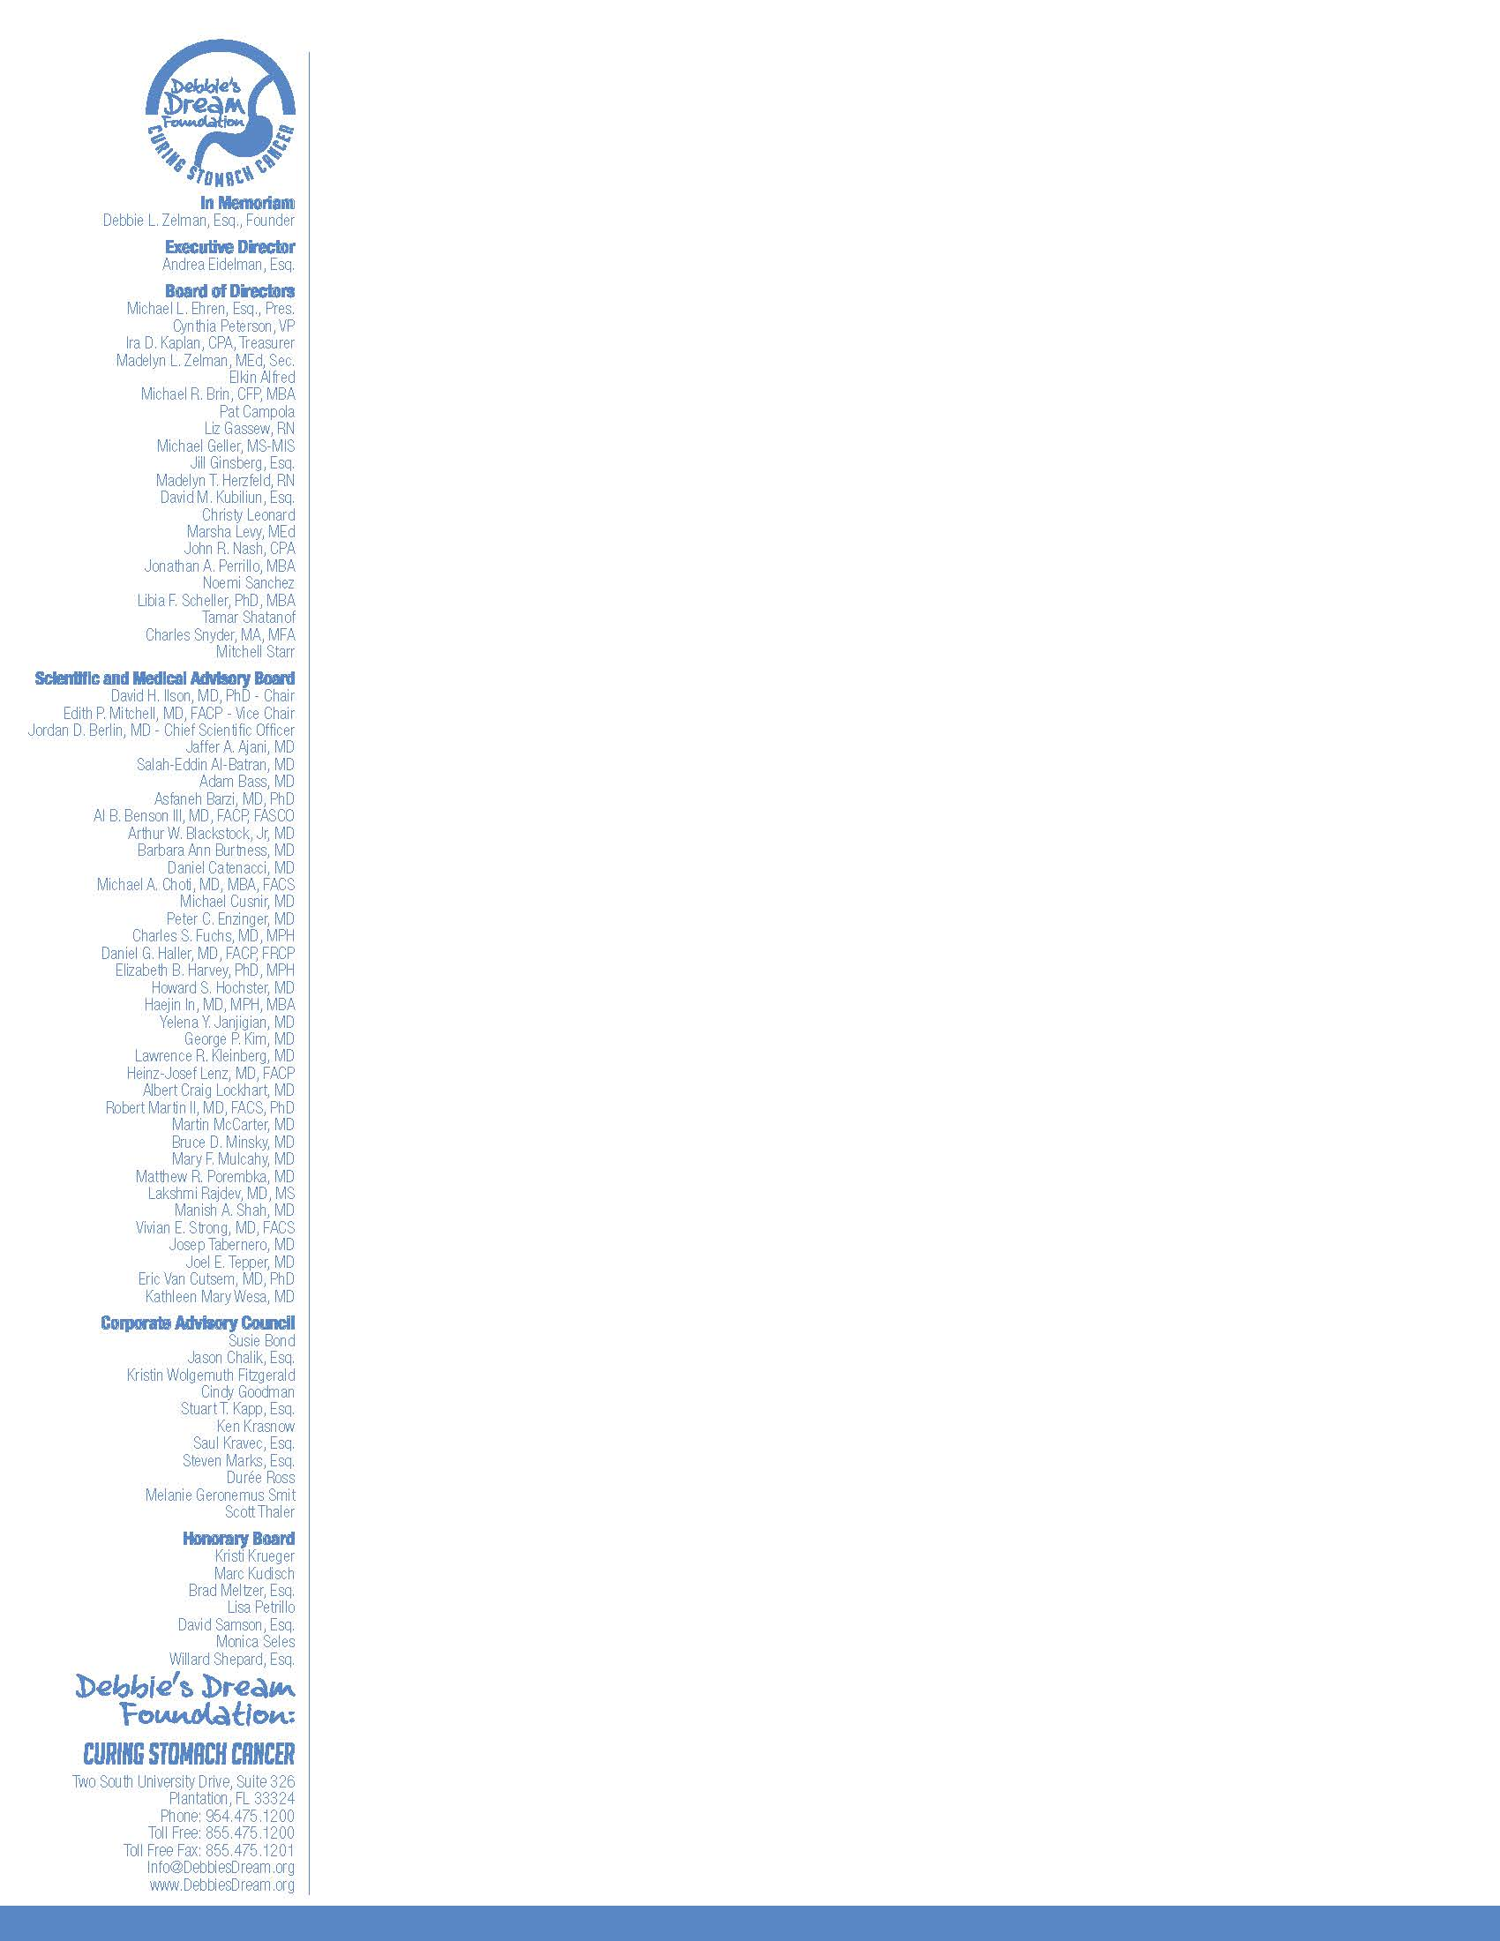

November 26, 2018

Dear Friend,

Debbie's Dream Foundation: Curing Stomach Cancer (DDF) is hosting its 10th Night of Laughter on Sunday, January 27, 2019, at Stage 954 Casino in Dania Beach, Florida. Debbie Zelman founded DDF in 2009, just one year after she was diagnosed with Stage IV advanced, incurable stomach cancer. When Debbie was diagnosed in 2008, her chance of being alive in five years was only four percent. There were no resources available for stomach cancer patients. There were – and still are – few treatment options for this devastating disease and no progress has been made in survival rates.

Unfortunately, Debbie passed away on December 23, 2017, at the age of 50, almost a decade later. DDF continues to carry out Debbie’s legacy to ensure that research remains a priority to increase the survival rates for this devastating disease.
DDF is the only organization that advocates for stomach cancer and provides free education and support/mentoring to stomach cancer patients, families, and caregivers. DDF is a 501(c)(3) non-profit organization dedicated to raising awareness about stomach cancer, advancing funding for research, and providing education and support internationally to patients, families, and caregivers. DDF seeks as its ultimate goal to make the cure for stomach cancer a reality.

We ask you to help with the success of our event by generously becoming an individual or corporate sponsor, placing an ad or tribute, and/or donating an auction item. Attached are the Sponsorship Levels, Ad / Tribute Information, Auction or In-Kind Donation Form, and the Commitment Form for your consideration. For further information about this event and to find out about the extraordinary difference DDF is making, please visit our website at www.DebbiesDream.org.

Thank you in advance for your support of Debbie's Dream Foundation: Curing Stomach Cancer and our 10th annual Night of Laughter.

With sincere appreciation,
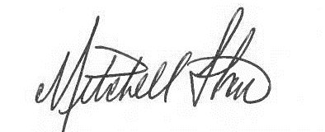

Mitchell Starr
Night of Laughter Chair

Jay Green | Stuart Lapayowker
Linda Green | Jodi Laurence, Esq.
Julie F. Klahr, Esq. | Adam Ross
Brooks Killmeyer | Caran Rothchild
 | Madelyn Zelman
Night of Laughter Committee Members

Tax Number 90-0470243 and DLN#17053272362009

A copy of the official registration and financial information may be obtained from the Division of Consumer Services BY calling toll-free within the State of Florida. Registration does not imply endorsement, approval, or recommendation by the State of Florida. The toll free number of the department is 1-800-HELP-FLA (435-7352) - calling from within the State of Florida, or (850) 488-2221 - calling from outside of Florida. The website is http://www.freshfromflorida.com/ which can also be used to look up officIal registration and financial information.

2019 Night of Laughter Sponsorship Levels

Headline Sponsor $10,000 ($9,280.00 is tax-deductible.)
Twelve (12) front row seats ♦ Opportunity to place a promotional item of value on tables ♦ Name/logo printed on the invitation, event collateral & signage ♦ Name/logo included on all event marketing ♦ Donor Spotlight on DDF website with link to your website ♦ Four sponsorship announcements on DDF social media pages♦ Public recognition during the event
Stand Up Sponsor $5,000 ($4,400.00 is tax deductible.)
Ten (10) tickets with premier reserved seating & exclusive table signage ♦ Name/logo printed on the invitation, all marketing, event collateral & signage ♦ Name/logo included on all event marketing & social media ♦ Donor Spotlight on DDF website with link to your website ♦ Public recognition during the event ♦ Public recognition during the event
Laugh Out Loud Sponsor $2,500 ($2,020.00 is tax-deductible.)
Eight (8) event tickets with reserved seating & exclusive table signage ♦ Name/logo printed on the invitation, event collateral & signage ♦ Name/logo included on all event marketing ♦ Donor Spotlight on DDF website with link to your website ♦ Two sponsorship announcements on DDF social media pages♦ Public recognition during the event
Funny Bone Sponsor $1,500 ($1,140.00 is tax-deductible.)
Six tickets (6) with reserved seating ♦ Name/logo included on all event marketing ♦ Donor Spotlight on DDF website with link to your website ♦ One sponsorship announcement on DDF social media pages♦ Public recognition during the event
Comic Relief Sponsor $750 ($515.00 is tax-deductible.)
Four (4) tickets with reserved seating ♦ Name/logo included on all event marketing ♦ Donor Spotlight on DDF website with link to your website ♦ One sponsorship announcement on DDF social media pages ♦ Public recognition during the event
Opening Act Sponsor $350 ($230.00 is tax-deductible.)
Two (2) tickets with reserved seating ♦ Logo/name displayed as Opening Act Sponsor ♦ Public recognition during the event ♦ Business card ad
Digital Program Ads/Tributes (Full donation is tax-deductible.)
♦ Full Page = $750
♦ Half Page = $450
♦ Quarter Page =$250
♦ Business Card = $100
2019 FLORIDA NIGHT OF LAUGHTER
SPONSOR AND ADS / TRIBUTES COMMITMENT FORM

Sponsor Information:
Sponsor Name (as you would like it to appear in print):
______________________________________________________________________________________
Contact Person: _________________________________________________________________________
Mailing Address:_________________________________________________________________________
City: ____________________________________________ State: _______ Zip Code: __________ - _____
Phone: ____________________________________ Fax: _______________________________________
E-mail Address: _________________________________________________________________________
Signature: _____________________________________________________________________________
Sponsorship Commitment Level and Ad / Tribute Space: All sponsorship forms, ads/tributes, & logos are due by January 10, 2019 unless otherwise indicated on the Sponsorship Levels. Logos must be sent to Events@DebbiesDream.org in high resolution, minimum 300DPI, .pdf, .jpg, or .tif format.
Digital Ad/Tribute Space
(See attached Night of Laughter Ad/Tribute Specifications.)
____ Full Page ($750)
____ Half Page ($450
____ Quarter Page ($250)
____ Business Card ($100)
Headliner Sponsor ($10,000)
Stand Up Sponsor ($5,000)
Laugh Out Loud Sponsor ($2,500)
Funny Bone Sponsor ($1,500)
Comic Relief Sponsor ($750)
Opening Act Sponsor ($350)

Method of Payment:
Check enclosed (payable to Debbie’s Dream Foundation)
Charge the following credit card: Visa MC AMEX

Card number: ___________________________________________Expiration date: ______________
Security code: _______________ (three digits on signature strip or four digits above card number)
Name on card (Please print clearly.):______________________________________________________
Signature: __________________________________________________________________________

Billing Address is the same as above.

Billing Address (if different): ________________________________________________________________
City: _________________________________________ State: _________ Zip Code: _________ - _______

DDF Volunteer Contact Name: _____________________________________________________________

Please return this form and payment to:
Debbie’s Dream Foundation: Curing Stomach Cancer
Attention: Florida Night of Laughter
Two South University Drive, Suite 326
Plantation, FL 33324

This form may be faxed to (855) 475-1201 or emailed to Events@DebbiesDream.org.

Debbie’s Dream Foundation: Curing Stomach Cancer (DDF) is a 501(c)(3) non-profit organization.
All sponsorships are tax deductible to the extent allowed by law. All sponsors will receive an acknowledgement from DDF.

2019 FLORIDA NIGHT OF LAUGHTER
AD / TRIBUTE SPECIFICATIONS

General Conditions and Deadlines:
All ad or tribute forms and images received by January 10, 2019 will be included in the digital program.
Please ensure that your full color, camera ready artwork conforms to the specifications below.
Digital Ad or Tribute | Price | Width | Height
Full Page | $750 | 5.5" | 8.50"
Half Page | $450 | 5.5" | 4.25"
Quarter Page | $250 | 2.75" | 4.25"
Business Card | $100 | 2.75" | 2.125”

- Artwork will not be returned.

- Ads and tributes must be submitted to size in full color, high resolution, minimum 300dpi, .pdf, .jpg, or .tif format and emailed to Events@DebbiesDream.org by January 10, 2019.

- Please note “2019 Florida Night of Laughter Ad” in subject line.
- All advertisements and their placement are subject to acceptance by Debbie’s Dream Foundation.
- Ads or tributes not formatted correctly will be returned and will need to be reformatted & resubmitted by the deadline. Debbie’s Dream Foundation will not reformat, resize or recolor ads.

For Text Only Ads / Tributes:
Please print or type requested text on the lines below or email it (preferred) to Events@DebbiesDream.org.

_____________________________________________________________________________________

_____________________________________________________________________________________

_____________________________________________________________________________________

Please return this completed form to:
Debbie’s Dream Foundation: Curing Stomach Cancer
Attention: Florida Night of Laughter
Two South University Drive, Suite 326
Plantation, FL 33324

2019 FLORIDA NIGHT OF LAUGHTER
RAFFLE/AUCTION OR IN-KIND DONATION FORM

Donor Information:
Donor Name (as you would like it to appear in print):
_____________________________________________________________________________________
Contact Person: ________________________________________________________________________
Mailing Address: _______________________________________________________________________
City: ____________________________________________State: _______ Zip Code: _________ - _____
Phone: ____________________________________ Fax: ______________________________________
E-mail Address: ________________________________________________________________________

Description of Product or Service (Please include any applicable restrictions.):___________________________
_____________________________________________________________________________________
_____________________________________________________________________________________
_____________________________________________________________________________________
_____________________________________________________________________________________

Value: $____________________ Date: _____________ Expiration Date (if any): _________________

Signature: ____________________________________________________________________________

Print Name: ___________________________________________________________________________

DDF Volunteer Contact Name: ____________________________________________________________

Please return this form and the donated item or gift certificate (if applicable) to:
Debbie’s Dream Foundation: Curing Stomach Cancer
Attention: Florida Night of Laughter
Two South University Drive, Suite 326
Plantation, FL 33324

This form may be faxed to (855) 475-1201 or emailed to Events@DebbiesDream.org.

Debbie’s Dream Foundation: Curing Stomach Cancer (DDF) is a 501(c)(3) non-profit organization.
All donations are tax deductible to the extent allowed by law. All donors will receive acknowledgements from DDF.

